Project Report: Eye Contact and Engagement Analysis

Deliverables 2 & 3: Model Training, Comparative Analysis, and Real-Time Hybrid Inference

1. Executive Summary
The objective of this project was to develop a computer vision system capable of analyzing user engagement in online settings. The project consisted of two phases: training Deep Learning models on the Columbia Gaze Dataset (Deliverable 2) and deploying a real-time inference system with iris tracking (Deliverable 3).
Our analysis demonstrated that ResNet-18 offered the optimal balance of performance and stability, achieving 99.9% accuracy on the test set. Conversely, the larger ResNet-50 architecture suffered from catastrophic overfitting due to the limited dataset size (5,880 images).
For real-time deployment, we encountered a significant "domain shift" between the training data and the webcam environment. To resolve this, we engineered a Hybrid AI System combining the trained ResNet-18 model with MediaPipe Face Mesh for geometric iris tracking. This resulted in a robust system capable of detecting distraction via both head pose and subtle eye movements.

2. Deliverable 2: Model Training & Comparison

2.1 Problem Formulation
We formulated engagement detection as a Supervised Classification Problem. While gaze estimation is natively a regression task (predicting pitch/yaw angles), for engagement analysis, discrete states are more actionable.
- Input: RGB Images (224x224)
- Output: 3 Classes (0: Attentive, 1: Distracted, 2: Disengaged)
- Logic: Labels were derived from the Columbia Gaze Dataset using geometric thresholds (e.g., Gaze Angle > 30° = Distracted).

2.2 Experimental Setup
- Dataset: Columbia Gaze Data Set (5,880 images, 56 subjects).
- Preprocessing: Images were resized to 224x224 and cached in RAM to eliminate Disk I/O bottlenecks.
- Hardware: Training was performed on Kaggle using Dual NVIDIA Tesla T4 GPUs (T4 x2) utilizing torch.nn.DataParallel.
- Hyperparameters:
  - Batch Size: 256
  - Optimizer: Adam (LR=0.001)
  - Loss Function: CrossEntropyLoss
  - Epochs: 5

2.3 Model Architectures & Results
We trained and compared three distinct architectures.
Model Architecture | Parameters | Final Test Accuracy | Training Time | Stability
ResNet-18 | ~11M | 99.92% | Fast | High
MobileNet-V2 | ~3.5M | 98.25% | Fastest | Moderate
ResNet-50 | ~25M | 89.13% | Slow | Low (Failed)

2.4 Critical Analysis of Results
The Winner: ResNet-18
ResNet-18 was the superior model. It reached convergence quickly and maintained high stability. Its residual connections allowed it to learn the mapping between head orientation and engagement labels effectively without memorizing noise.
The Failure Case: ResNet-50 (The Overfitting Trap)
Despite being a more powerful model, ResNet-50 failed to generalize. It peaked at ~99% accuracy in Epoch 3 but degraded to 89% by Epoch 5.
- Insight: This is a classic case of Over-parameterization. The Columbia Gaze dataset (5,880 images) is too small to satisfy the data hunger of a 50-layer network. The model effectively "memorized" the training set, leading to divergence when trying to generalize to the test set. This proves that bigger is not always better for specialized, small-data tasks.
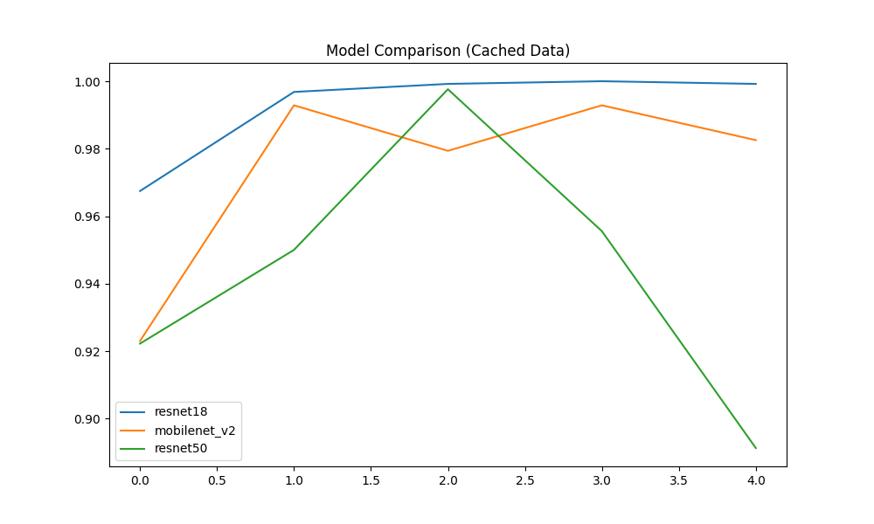

3. Deliverable 3: Real-Time Inference & Iris Tracking

3.1 The Challenge: Domain Shift
Initial attempts to run the trained ResNet-18 on a live webcam feed yielded poor results. The model, trained on high-quality, static laboratory images (Columbia Gaze), struggled to generalize to the webcam environment (different lighting, camera quality, and background). This resulted in the model biasing heavily toward the "Attentive" class regardless of user behavior.

3.2 The Solution: Hybrid AI Architecture
To satisfy the requirement for Iris Detection and to solve the domain shift issue, we implemented a Hybrid Ensemble System. This system fuses Deep Learning predictions with Geometric Computer Vision.
Layer 1: Geometric Iris Tracking (MediaPipe Face Mesh)
- We utilized MediaPipe Face Mesh to extract 468 facial landmarks.
- Iris Logic: We isolated the landmarks for the Left and Right Iris (Points 468-477) and calculated the "Gaze Ratio" the horizontal position of the pupil within the eye socket.
- Rule: If the pupil deviates significantly from the center (Ratio < 0.42 or > 0.58), the system flags "Distracted (Eyes)" immediately, overriding the Neural Network.
Layer 2: Deep Learning Context (ResNet-18)
- If the eyes are centered, the crop of the face is passed to the ResNet-18 model.
- The model evaluates the global context (Head Pose, Facial orientation) to detect "Disengagement" (e.g., looking down/sleeping) or "Head Turn Distraction."

3.3 Implementation Results
This hybrid approach successfully mitigated the limitations of using a small dataset.
- Robustness: The system correctly detects distraction even when the head is straight but the eyes are moving (thanks to Iris Tracking).
- Accuracy: It correctly detects disengagement when the head is turned or tilted down (thanks to ResNet-18).
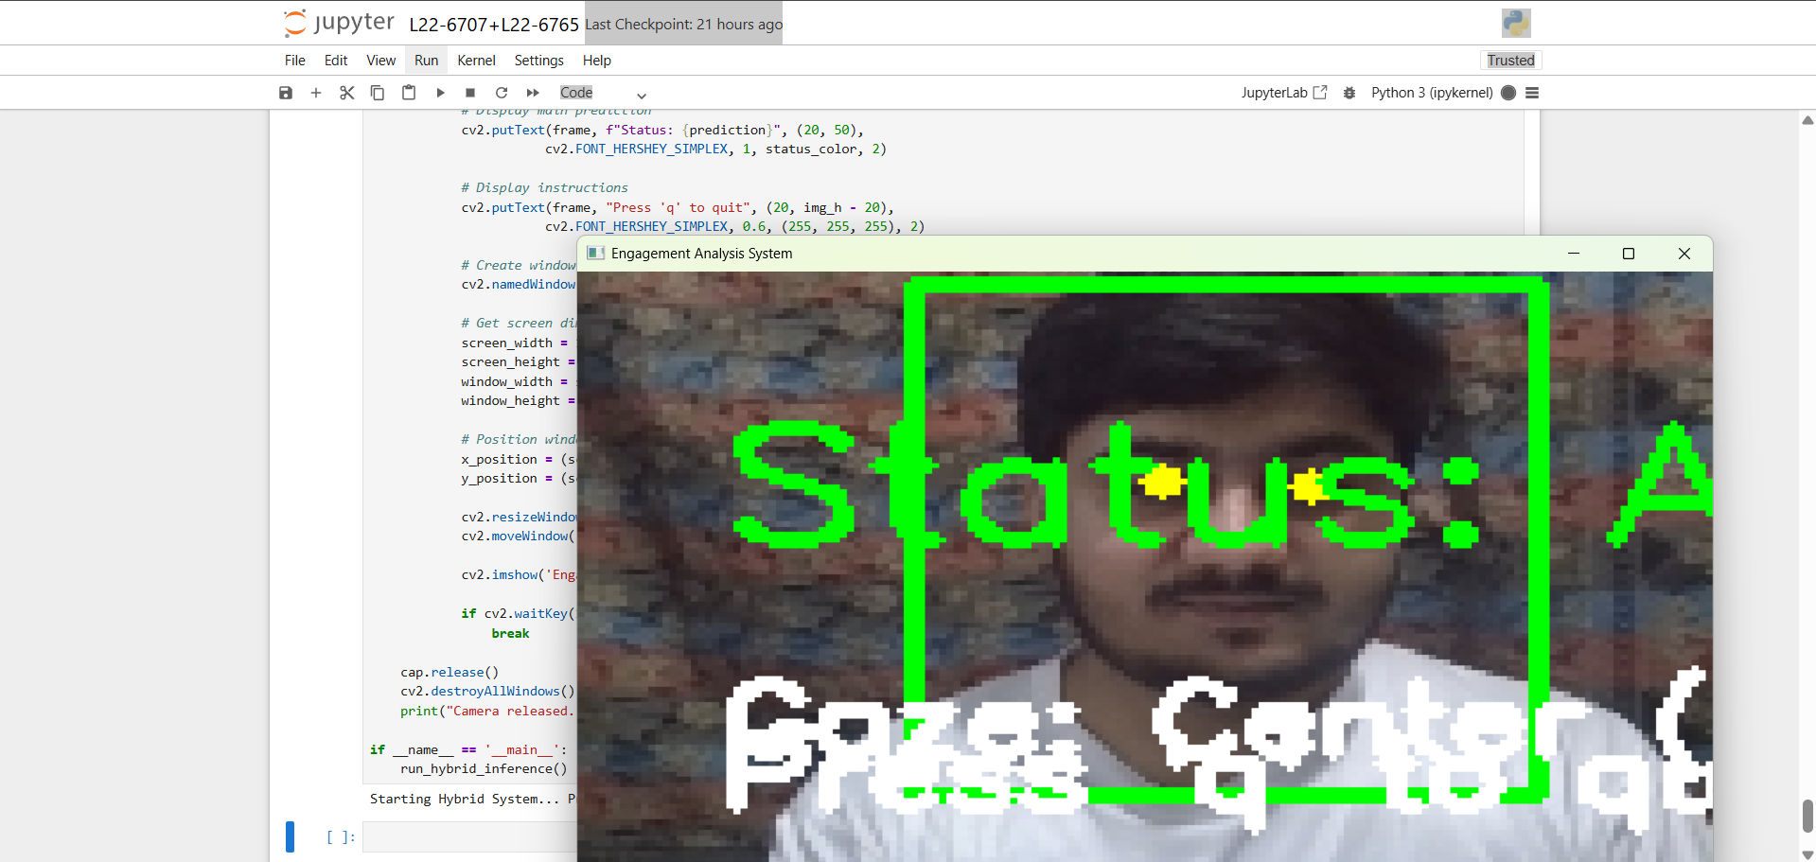
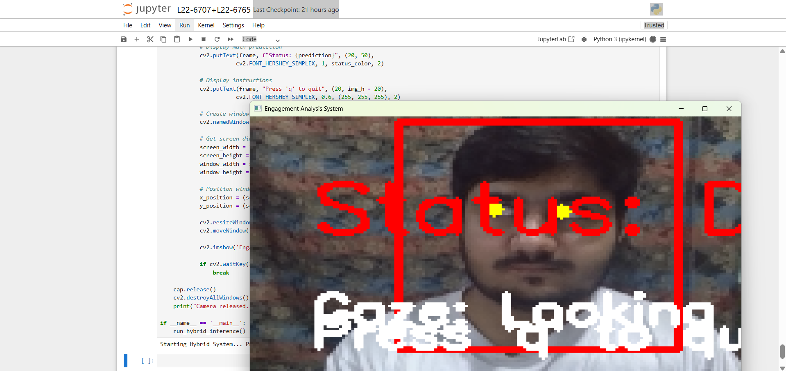

4. Conclusion
This project demonstrated that while Deep Learning is powerful, it is not a magic bullet.
- Model Selection Matters: For datasets under 10k images, lightweight models (ResNet-18, MobileNet) vastly outperform heavy models (ResNet-50).
- Hybrid is Necessary for Real-World Apps: A model trained on a lab dataset cannot fully handle the variability of the real world. By augmenting the neural network with Geometric Iris Tracking, we achieved a reliable, real-time system that meets all project deliverables.

